**Amrita Vishwa Vidyapeetham**

**Amrita School of Engineering, Coimbatore**

**Department of Computer Science and Engineering**

**Topic: Threads Practice**

------------------------------------------------------------------------------------------------**19CSE213 Operating Systems Laboratory – Threads Practice**

1. **Simple Program :**

#include <stdio.h>

#include <stdlib.h>

#include <unistd.h>

#include <pthread.h>

void *myThreadFun(void *ab)

{

sleep(1);

printf("Printing Srings from threads \n");

return NULL;

}

int main()

{

pthread_t thread_id;

printf("Before Thread\n");

pthread_create(&thread_id, NULL, myThreadFun, NULL);

pthread_join(thread_id, NULL);

printf("After Thread\n");

exit(0);

}

* **Explaination :**
* In main() we declare a variable called thread_id, which is of type pthread_t. After declaring thread_id, we call pthread_create() function.
* The first argument is a pointer to thread_id
* The second argument specifies attributes. If it is NULL, then default attributes shall be used.
* The third argument is name of function to be executed for the thread to be created.
* The fourth argument is used to pass arguments to the function.

**Output :**

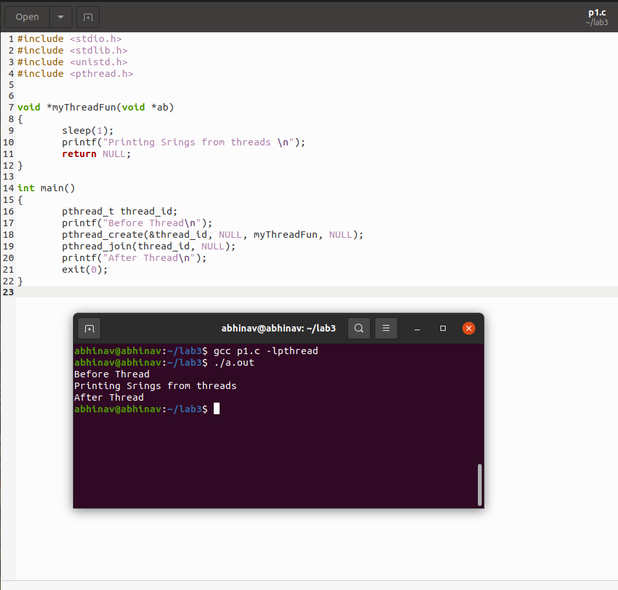

**2.With global and static variables:**

#include <stdio.h>

#include <stdlib.h>

#include <unistd.h>

#include <pthread.h>

int g = 0;

void *myThreadFun(void *vargp)

{

int *myid = (int *)vargp;

static int s = 0;

++s; ++g;

printf("Thread ID: %d, Static: %d, Global: %d\n", *myid, ++s, ++g);

}

int main()

{

int i;

pthread_t tid;

for (i = 0; i < 3; i++)

pthread_create(&tid, NULL, myThreadFun, (void *)&tid);

pthread_join(tid,NULL);

pthread_exit(NULL);

return 0;

}

**Output :**

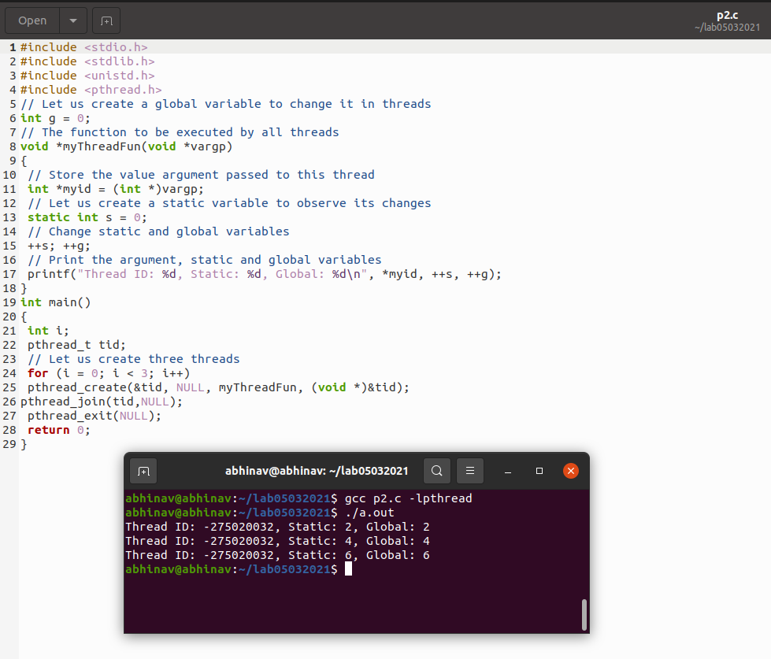

**3. 2 Threads :**

#include <stdio.h>

#include <stdlib.h>

#include <pthread.h>

#include <unistd.h>

void *SampleThread1(void *vargp)

{

int i = 0;

printf("SampleThread(1) is running ... \n");

for(i = 0; i < 10; i++) {

sleep(1);

printf("timer running inside SampleThread(1) = %d\n", i);

}

printf("SampleThread(1) is exiting ... \n");

return NULL;

};

void *SampleThread2(void *vargp)

{

int i = 0;

printf("SampleThread(2) is running ... \n");

for(i = 0; i < 15; i++) {

sleep(1);

printf("timer running inside SampleThread(2) = %d\n", i);

}

printf("SampleThread(2) is exiting ... \n");

return NULL;

};

int main()

{

int i = 0;

pthread_t tid1, tid2;

pthread_create(&tid1, NULL, SampleThread1, NULL);

pthread_create(&tid2, NULL, SampleThread2, NULL);

for(i = 0; i < 7; i++) {

sleep(2);

printf("timer running outside thread = %d\n", i);

}

printf("timer outside Thread is ended ..\n");

pthread_join(tid1, NULL);

pthread_join(tid2, NULL);

exit(0);

}

**Output :**

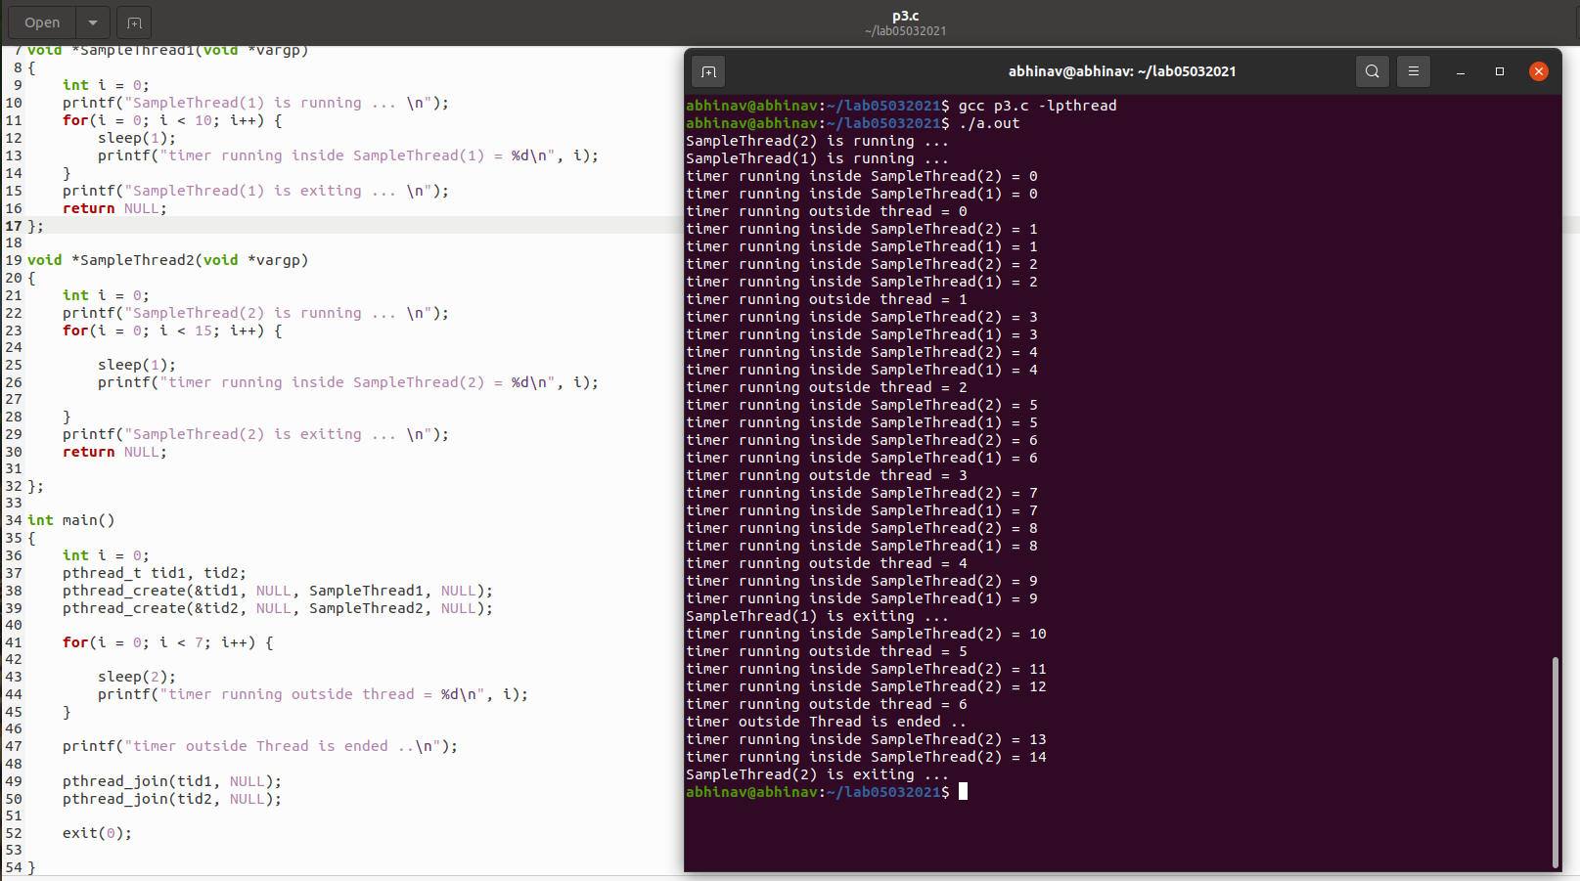

**4.Passing 1 Argument :**

#include <stdio.h>

#include <pthread.h>

void * hello(void *input) {

printf("%s\n", (char *)input);

pthread_exit(NULL);

}

int main(void) {

pthread_t tid;

pthread_create(&tid, NULL, hello, "Hello World!!!");

pthread_join(tid, NULL);

return 0;

}

**Output :**

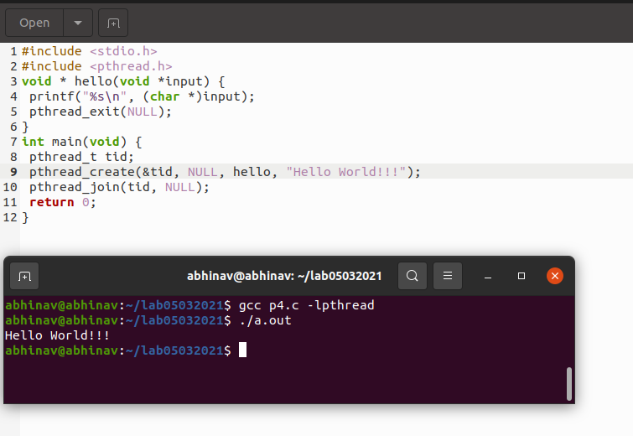

**5.Structure :**

#include <pthread.h>

#include <stdio.h>

#include <stdlib.h>

struct args {

char* name;

int age;

};

void *hello(void *input) {

printf("name: %s\n", ((struct args*)input)->name);

printf("age: %d\n", ((struct args*)input)->age);

}

int main() {

struct args *Allen = (struct args *)malloc(sizeof(struct args));

char allen[] = "Allen";

Allen->name = allen;

Allen->age = 20;

pthread_t tid;

pthread_create(&tid, NULL, hello, (void *)Allen);

pthread_join(tid, NULL);

return 0;

}

**Output :**

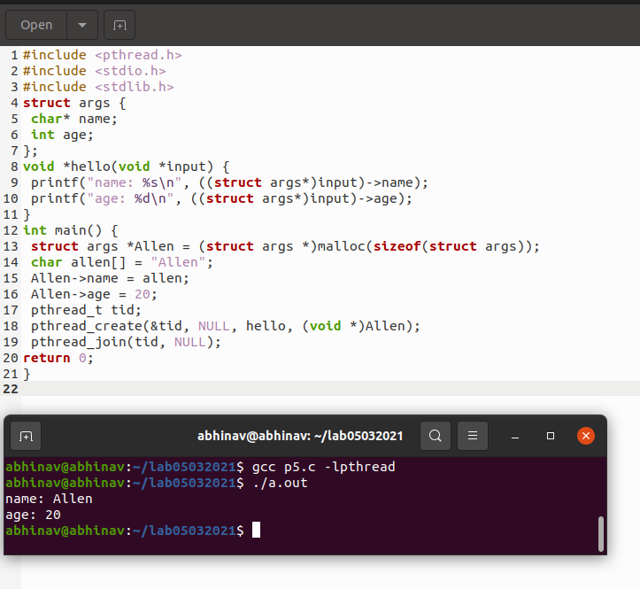

**6.Arrays :**

#include <pthread.h>

#include <stdio.h>

#include <unistd.h>

#include <stdlib.h>

#define NUM_THREADS 8

char *messages[NUM_THREADS];

void *PrintHello(void *threadid)

{

int *id_ptr, taskid;

sleep(1);

id_ptr = (int *) threadid;

taskid = *id_ptr;

printf("Thread %d: %s\n", taskid, messages[taskid]);

pthread_exit(NULL);

}

int main(int argc, char *argv[])

{

pthread_t threads[NUM_THREADS];

int *taskids[NUM_THREADS];

int rc, t;

messages[0] = "English: Hello World!";

messages[1] = "French: Bonjour, le monde!";

messages[2] = "Spanish: Hola al mundo";

messages[3] = "Klingon: Nuq neH!";

messages[4] = "German: Guten Tag, Welt!";

messages[5] = "Russian: Zdravstvytye, mir!";

messages[6] = "Japan: Sekai e konnichiwa!";

messages[7] = "Latin: Orbis, te saluto!";

for(t=0;t<NUM_THREADS;t++)

{ taskids[t] = (int *) malloc(sizeof(int));

*taskids[t] = t;

printf("Creating thread %d\n", t);

rc = pthread_create(&threads[t], NULL, PrintHello, (void *) taskids[t] );

if (rc) {

printf("ERROR; return code from pthread_create() is %d\n", rc);

exit(-1);

}

}

pthread_exit(NULL);

}

**Output :**

